Process Definition Documentation

(PDD)

|  |  |  |  |
| --- | --- | --- | --- |
| **Customer Identifiers** | | | |
| **Project Name :** | Third Eye – Citizen Portal to Report Violations | | |
| **Developed By :** | Vishnuvarthan Ponnuraj | | |
| **Work Email :** | [Vishnuvarthan.ponnuraj@dhl.com](mailto:Vishnuvarthan.ponnuraj@dhl.com) | | |
| **Email :** | Vishnuvarthan47@gmail.com | | |
|  |  |  |  |
|  |  |  |  |

Table of Contents

Table of Contents 1

1 Change tracker 2

2 PDD – Introduction 3

3 PDD – Steps Description 4

3.1 Overview 4

3.1.1 Process Overview 4

3.1.2 Target Systems 4

3.2 Process Flow diagram 5

3.3 Process Steps 6

3.3.1 Happy Path 6

3.3.2 Traffic Violation Bot : 9

3.3.3 Document Understanding Bot 11

4 Components DESCRIPTION: 12

4.1 Data Service 12

4.2 Document Understanding 15

5 Assumptions 15

# Change tracker

|  |  |  |  |
| --- | --- | --- | --- |
| Version | Date of Change | Name | Purpose of Change |
| 001 | 11/18/2020 | Vishnuvarthan Ponnuraj | Initial version of the document |

# PDD – Introduction

Process Definition Document (PDD) captures:

**Process Steps Description** – This chapter depicts about the highlevel description about the process

* The flowchart contained within the document captures, at a high level, the target systems used within the process and any assumptions that have been considered.

# PDD – Steps Description

Process steps desription captures and defines the process to be automated. It gives a clear vision about step-by-step process execution, parameters and exceptions to be considered when final solution would be automated.

## Overview

### Process Overview

This chapter depicts about the highlevel description about the process .

The Third eye Web portal allows the Citizens to report any violations done by the fellow citizens . This also allows the the reported Violations to be checked through the portal and the status . The Part of communicating the violations are done automatically through the Email and the interactions with the User to receieve / Request For informations are handled by the Bot . This process uses Document Understanding to extract Information from the Vehicle Image and Uses Action Centre to Validate and to approve / Reject the respetive informations . All the informations are stored in the Data Service entity .

Components Used :

|  |  |
| --- | --- |
| Components | Used for |
| Uipath Apps | Third eye Portal (front End) |
| Data Service | To Store and Retrieve Data |
| Document Understanding | Extract Information from the vehicle Image |
| Action Centre | To Validate Results |

### Target Systems

The table includes a comprehensive list of all the applications that are used as a part of the process automated,at various steps in the flow.

|  |  |  |
| --- | --- | --- |
| Name | Type | Description |
| Third Eye | WEB | Used to Report Traffic Violations and Check the reported Violations |
| Microsoft Azure Computer vision OCR | API | Used to digitize the document as part of the Document Understanding |
| Uipath Orchestrator | WEB | Action Centre is required for Approving/ Rejecting Any Violations |
| Uipath Data Service | WEB | To store/ Retrieve Data Models. |

## Process Flow diagram

This Chapter depicts the AS IS Business Process in detail :

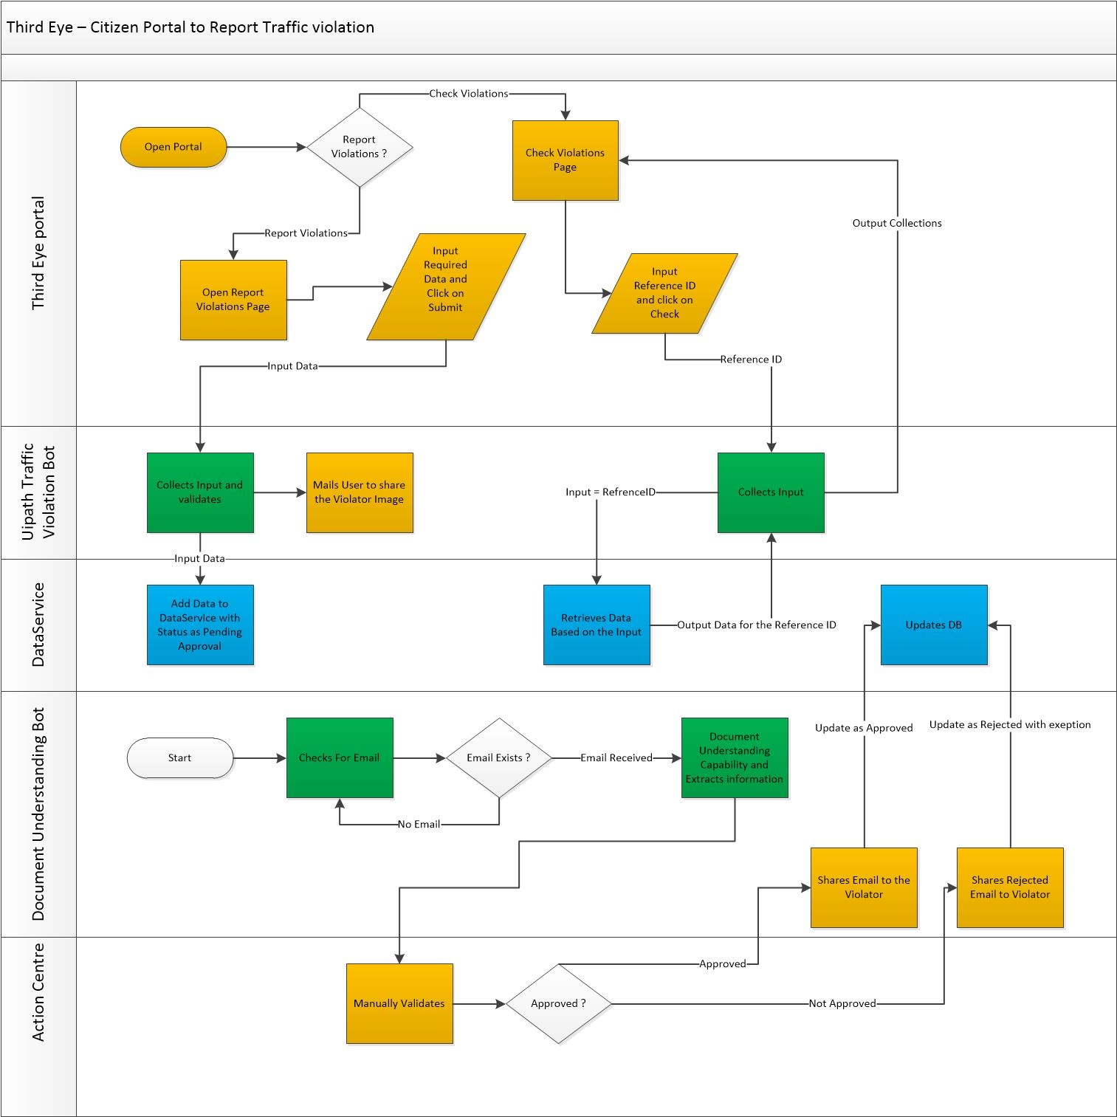

## Process Steps

### Happy Path

This Chapter describes all ideal situations where everything would function as expected

|  |  |  |  |  |  |
| --- | --- | --- | --- | --- | --- |
| **#** | **Step Description** | **Screenshot** | **Expected Result** | **Parameter** | **Parameter source** |
| 1 | **User Opens Third Eye Portal.**  **Url :** [**https://cloud.uipath.com/vishnu123/apps_/default/run/default/ID0154cdb219374f77954ee98ed72bf95e**](https://cloud.uipath.com/vishnu123/apps_/default/run/default/ID0154cdb219374f77954ee98ed72bf95e) |  |  |  |  |
| 2 | **Goto step 3, for Report Violations.**  **Goto step 7 for Check Violations** |  | Opens Report Violations Page |  |  |
| 3 | **Inputs all the fields such as Vehicle No, Offence, Location and Submitter Email ID.** |  | If any of the fields are missing , Website will prompt to enter all the respective information |  | Input fields |
| 4 | **Click Submit** |  | Triggers The Traffic Violations Bot ( Refer 3.3.2 and Step 2 ) | Data Entered is Binded with the input Parameters of The traffic Violations Bot Kick starts and adds the Record to the Entity - Traffic Violation and Returns **Challan ID** | Traffic Violation Bot |
| 5 | **Opens Report Submitted Page and Displays the Challan ID received from the Traffic Violation Bot.** |  |  |  |  |
| 6 | **Click Home** |  | Home page is opened. |  |  |
| 7 | **Enter Challan ID and click on Check** |  | Traffic Violation Bot is triggered | Location , Status , Vehicle No | Traffic Violation Bot |
| 8 | **Displays the Location , Status , Vehicle No to the users** |  |  |  |  |

### Traffic Violation Bot :

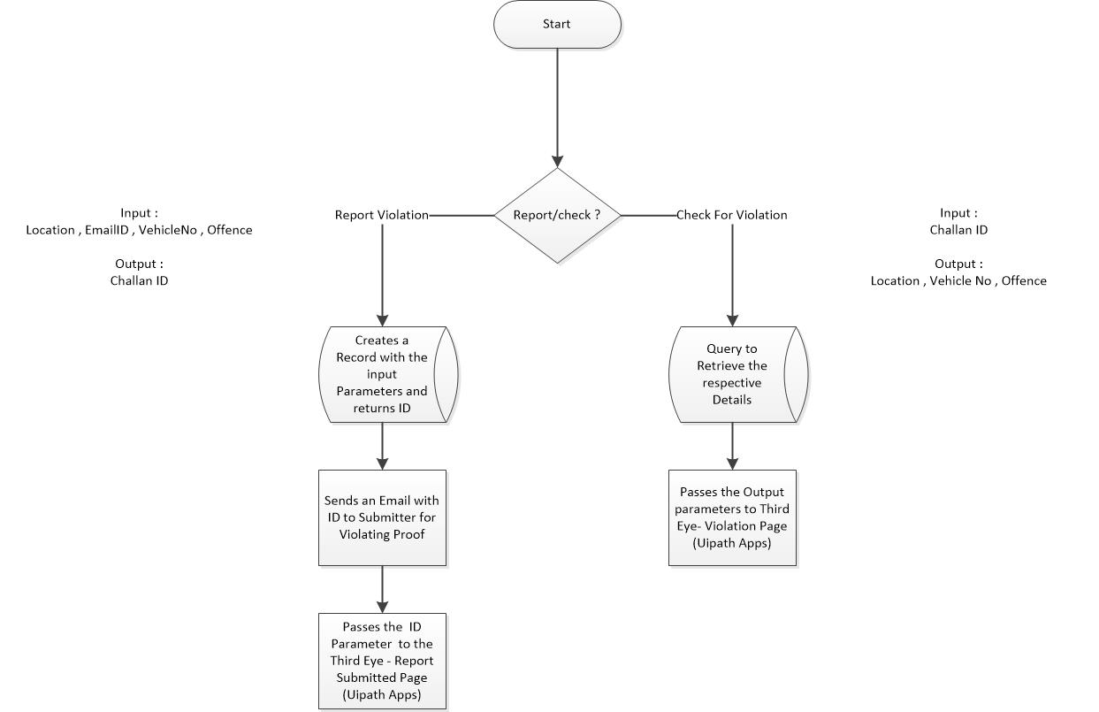

|  |  |  |  |  |
| --- | --- | --- | --- | --- |
| # | Step Description | Expected Result | Parameter | Parameter source |
| 1 | **If Bot is triggered on clicking Submit as part of 3.3.1 & Step 4, Goto Step 2.**  **For 3.3.1 & step 7 , GoTo step 6** |  |  |  |
| 2 | **Bot Starts to Process the respective Information.** |  | Input :  Location <string> , Offence<String> , EmailId<String> , VehicleNo <String>  Output :  ID<String> | Third eye (Uipath App) |
| 3 | **Bot Creates a Record in the Traffic Violation Entity with Status as “Pending Approval”** | Returns the Output Parameter challan Id |  | DataService |
| 4 | **Sends an Email to the Submitter to submit the Violating image proof** |  |  |  |
| 5 | **Returns the challan Id to the Report Submitted Page.** | Returns the Challan Id to Report Submitted Page ( Step 3.3.1 and Step 5 ) |  |  |
| 6 | **Bot queries the Uipath Data Service Entity – Traffic Violation with the Challan ID** | Returns the Record matching the challan ID | Input : challan ID  Output : Location , Status , Vehicle No | Third Eye(Uipath Apps) / Data Service |
| 7 | **Returns the Output Parameters to Step 3.3.1 & step 8** |  |  |  |

### Document Understanding Bot

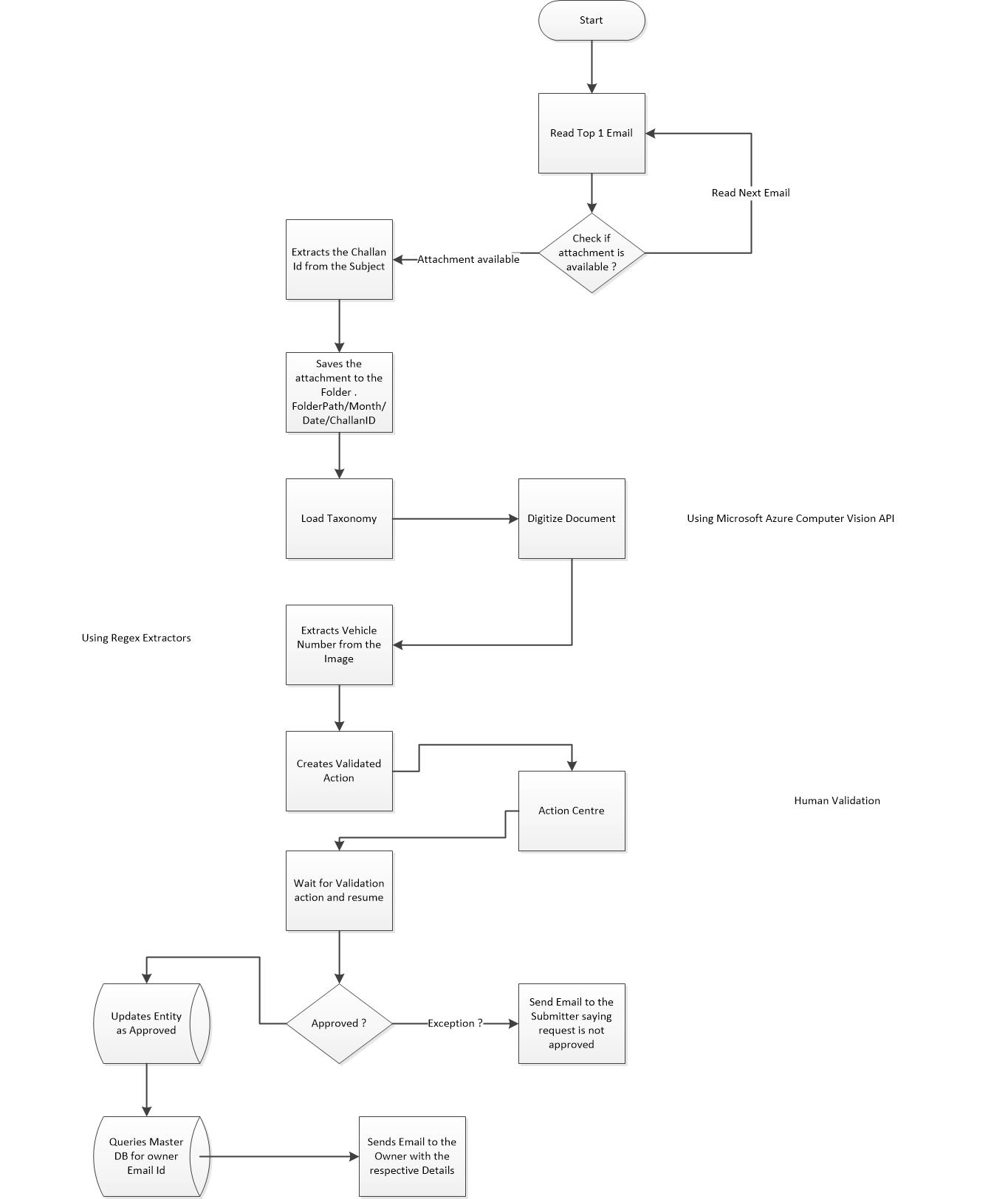

Step 1 : Bot Reads Email from the specialized folder

Step 2 : If Attachment Exists and Subject matches , Goto steps 3 else Goto Step 1

Step 3 : Digitize the Image

Step 4 : Extract the VehicleNo from the image using Regex Extractors

Step 5 : Create Validate Action

Step 6 : Reviewer Approves/Reject the Violation based on the Image Provided **(Human in loop)**

Step 7 : If Approved ,Go to Step 8 else Goto Step 12.

Step 8 : Updates the Entity Record of Traffic Violation with Status As approved

Step 9 : If Vehicle Number is mismatched between the report submitted and the image provided , Bot will Update the Vehicle No as of the image .

Step 10 : Retrieve the owner Details from Vehicle Database Entity

Step 11 : Mail the Owner with the Challan details and the respective offence .

Step 12: If rejected , mail the submitter with the respective reason .

# Components DESCRIPTION:

## Data Service

Entity Used : TrafficViolation , Vehicle Database

Schema : Traffic Violation

|  |  |  |  |  |
| --- | --- | --- | --- | --- |
| Display Name | Name | Type | Required | Description |
| Id | Id | UniqueId | Yes | System built-in field |
| Approved | Approved | Text | Yes | Status |
| Date | Date | Date-Time | Yes | Reported Date |
| EmailID | EmailID | Text | Yes | Submitter Email Id |
| Location | Location | Text | Yes | Location of offence |
| Offence | Offence | Text | Yes | Reported offence |
| Vehicle No | VehicleNo | Text | Yes | Vehicle No |
| CreatedBy | CreatedBy | UniqueId | Yes | System built-in field |
| CreateTime | CreateTime | Date-Time | Yes | System built-in field |
| UpdatedBy | UpdatedBy | UniqueId | No | System built-in field |
| UpdateTime | UpdateTime | Date-Time | No | System built-in field |

Schema : VehicalDatabase

|  |  |  |  |  |
| --- | --- | --- | --- | --- |
| Display Name | Name | Type | Required | Description |
| Id | Id | UniqueId | Yes | System built-in field |
| EmailID | EmailID | Text | Yes | Owner Email ID |
| VehicleNumber | VehicleNumber | Text | Yes | Vehicle Number |
| CreatedBy | CreatedBy | UniqueId | Yes | System built-in field |
| CreateTime | CreateTime | Date-Time | Yes | System built-in field |
| UpdatedBy | UpdatedBy | UniqueId | No | System built-in field |
| UpdateTime | UpdateTime | Date-Time | No | System built-in field |

## Document Understanding

* Third Eye Uses Document understanding and Action Centre to extract information from the vehicle Images and Validate. This ensures that the data doesn’t go into the system without being validated.
* The Document Validated Actions are uploaded with the combination of Offence_VehicleNumber.

|  |  |  |
| --- | --- | --- |
| * OCR | * Microsoft Azure Computer Vision OCR | * Used to digitize Text from the Image |
| * Extractor | * Regex Based Extractor | * To Extract the Vehicle Number from the Digitized Text |
| * Action Centre | * Allows to Validate the Image being submitted against the offence. Helps to Reject / approve / Correct the data being input | |

# Assumptions

1. Vehicle database is prepopulated with the Master vehicle details.